Remember: You have to change the Directory in app.config file whenever you move this project to a new folder!
Steps of Fixing the WPF and Adding a new Connection to Visual Studio Data Connections

In App.config here’s what I have written for Data Directory (i.e – My Application Folder)
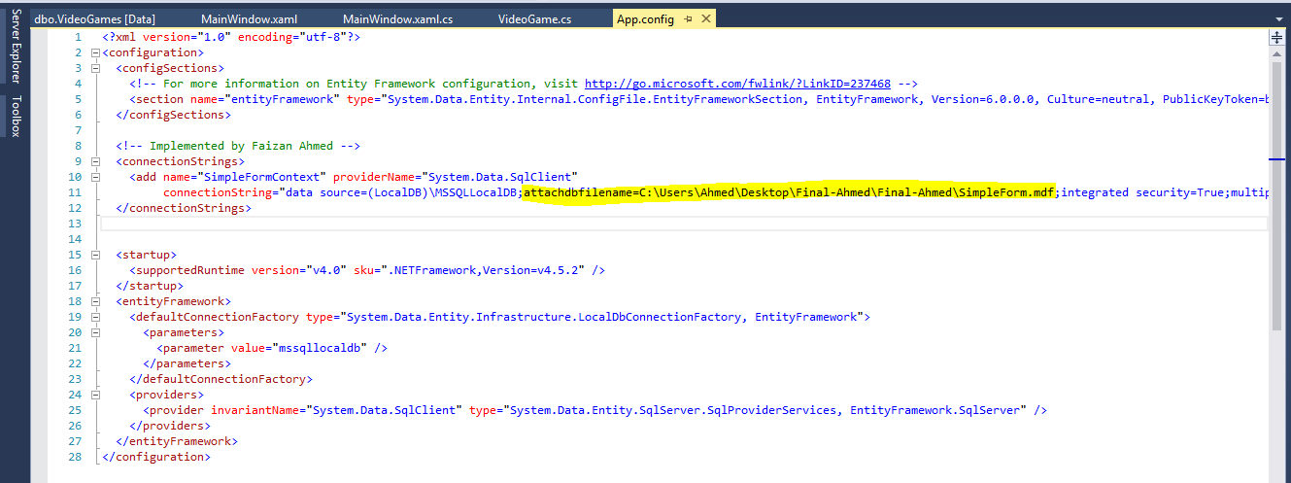

Steps for Creating New connection to the Database:
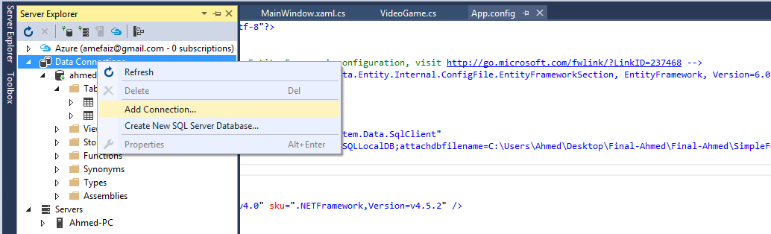
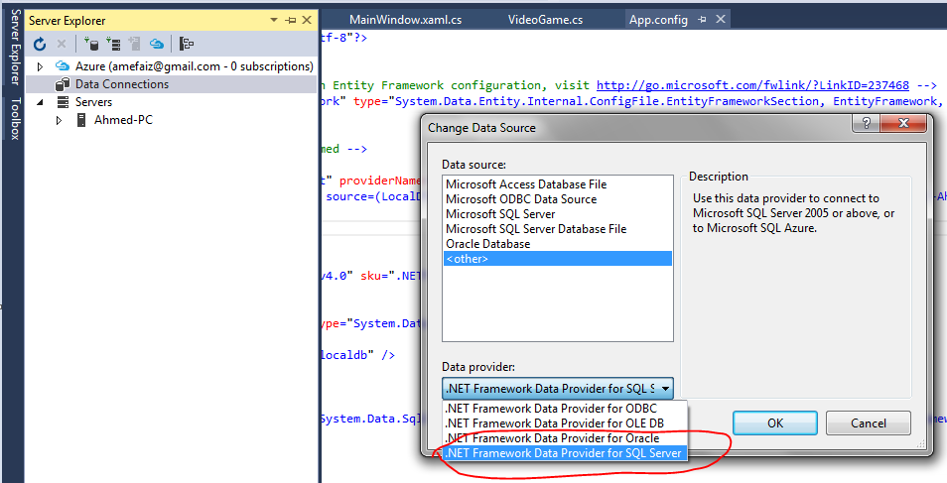
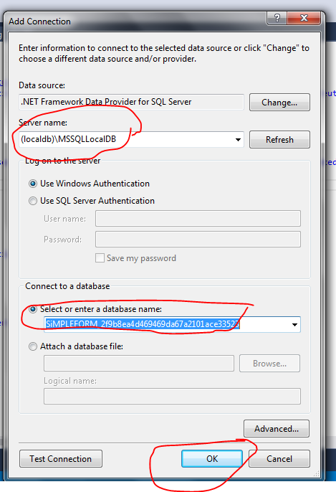
(localdb)\MSSQLLocalDB

